**Practical - 1**

**Aim:**

An organization named Green Tech Solution contains 2 departments: Production and Sales in the same premises. Each department has 3 users. Departments are connected with each other using switches. Report the changes in ARP table when any user from production department communicates with any user of sales department.

**Task 1:**

To compare working of HUB and SWITCH HUB:

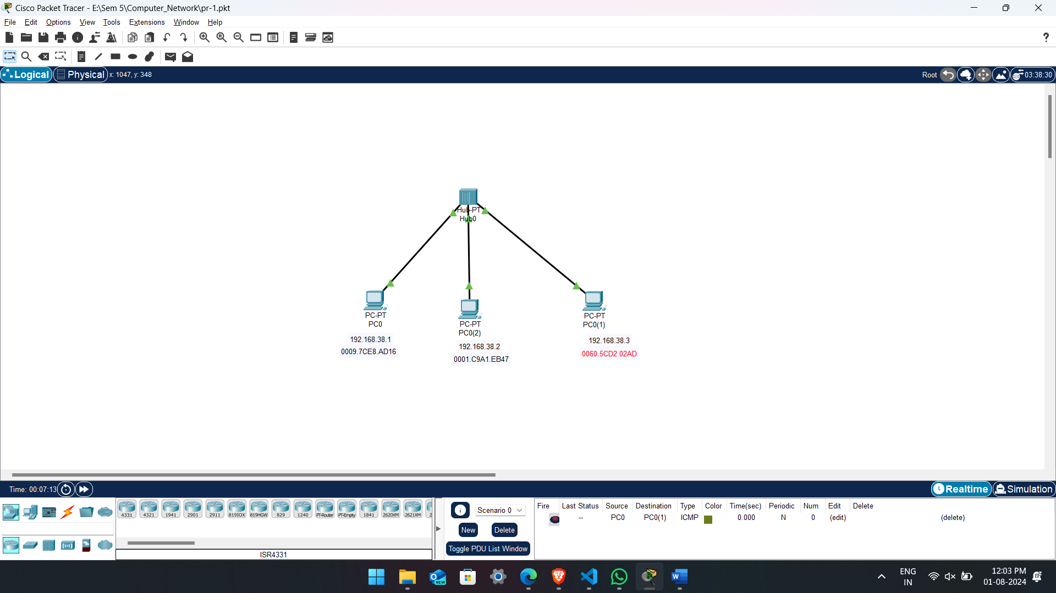

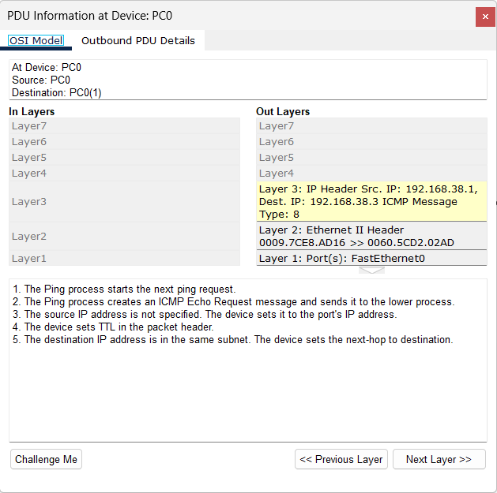

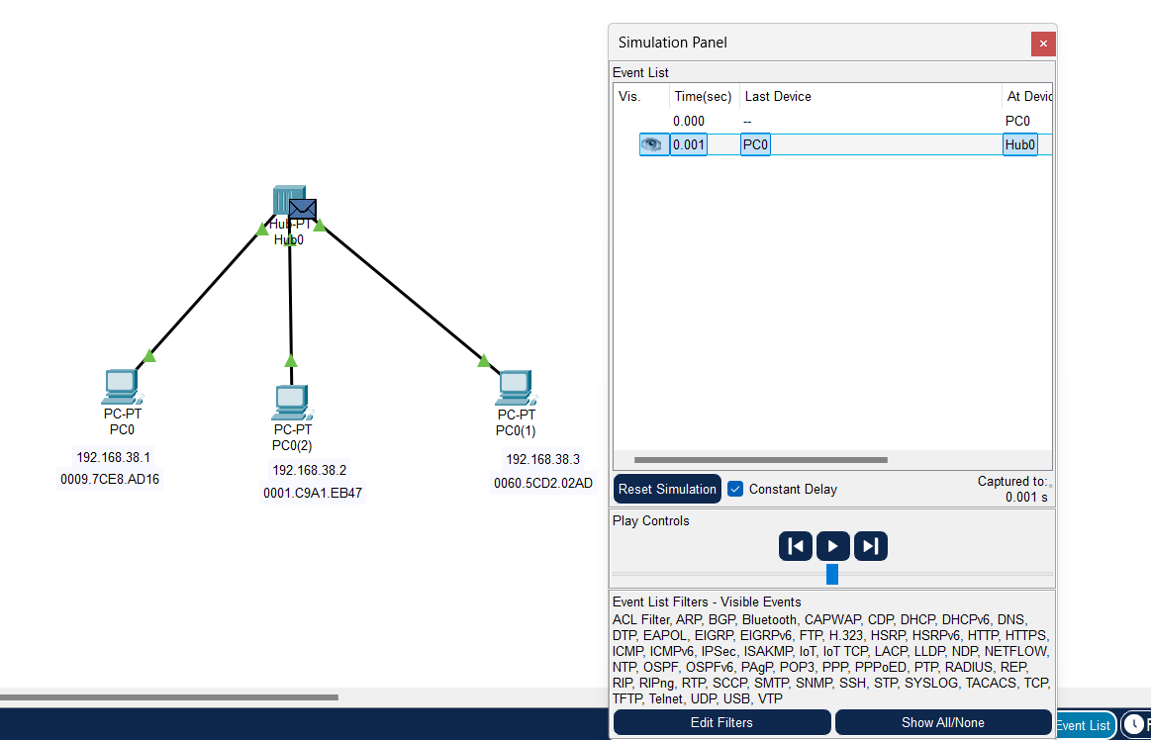

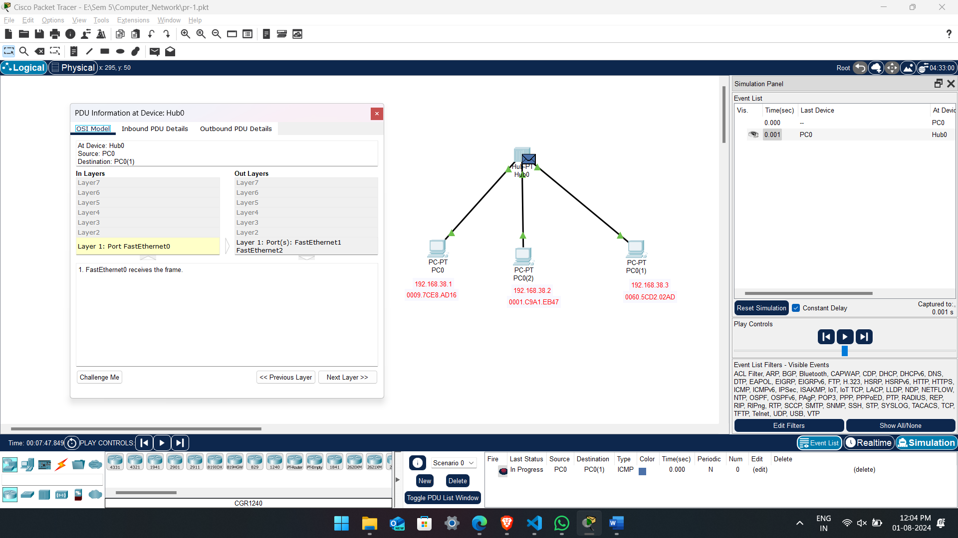

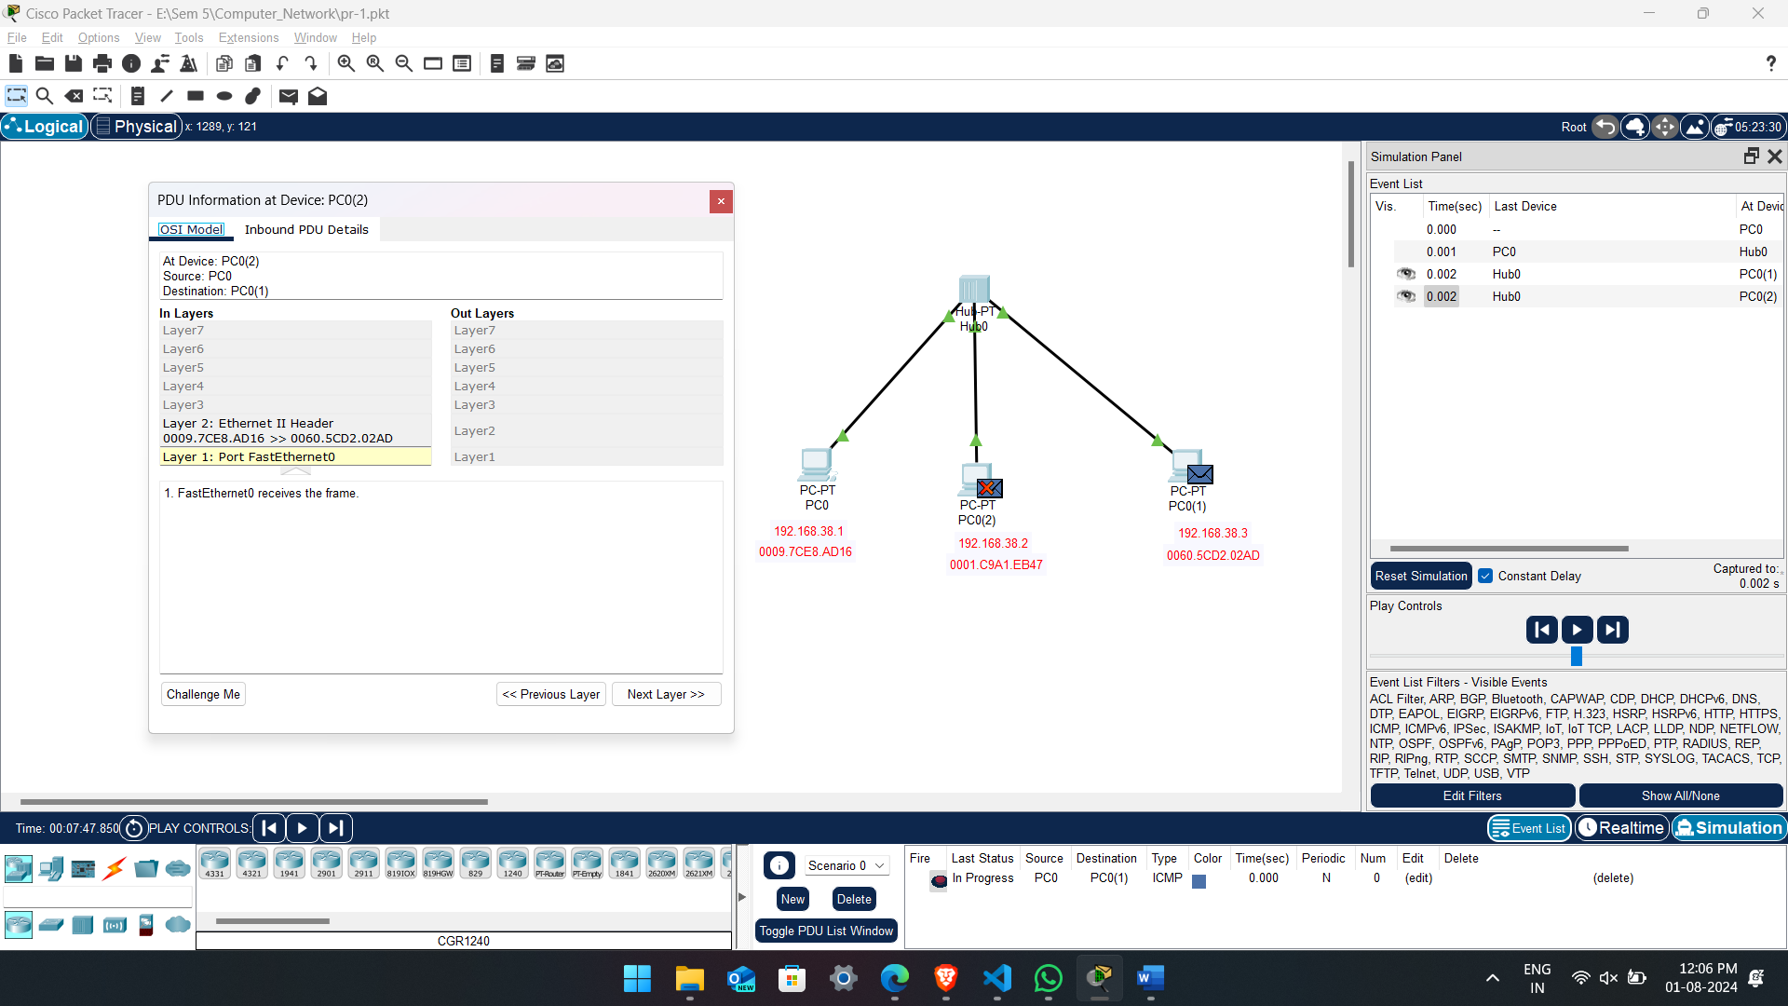

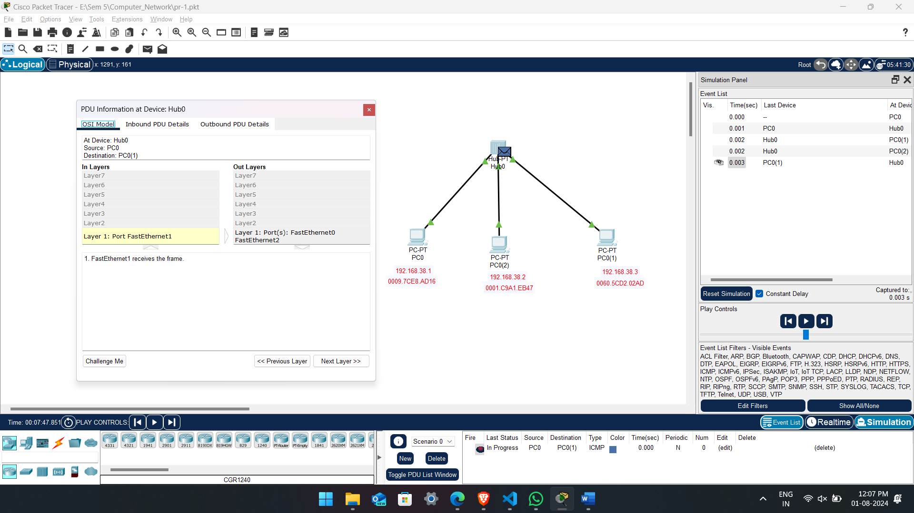

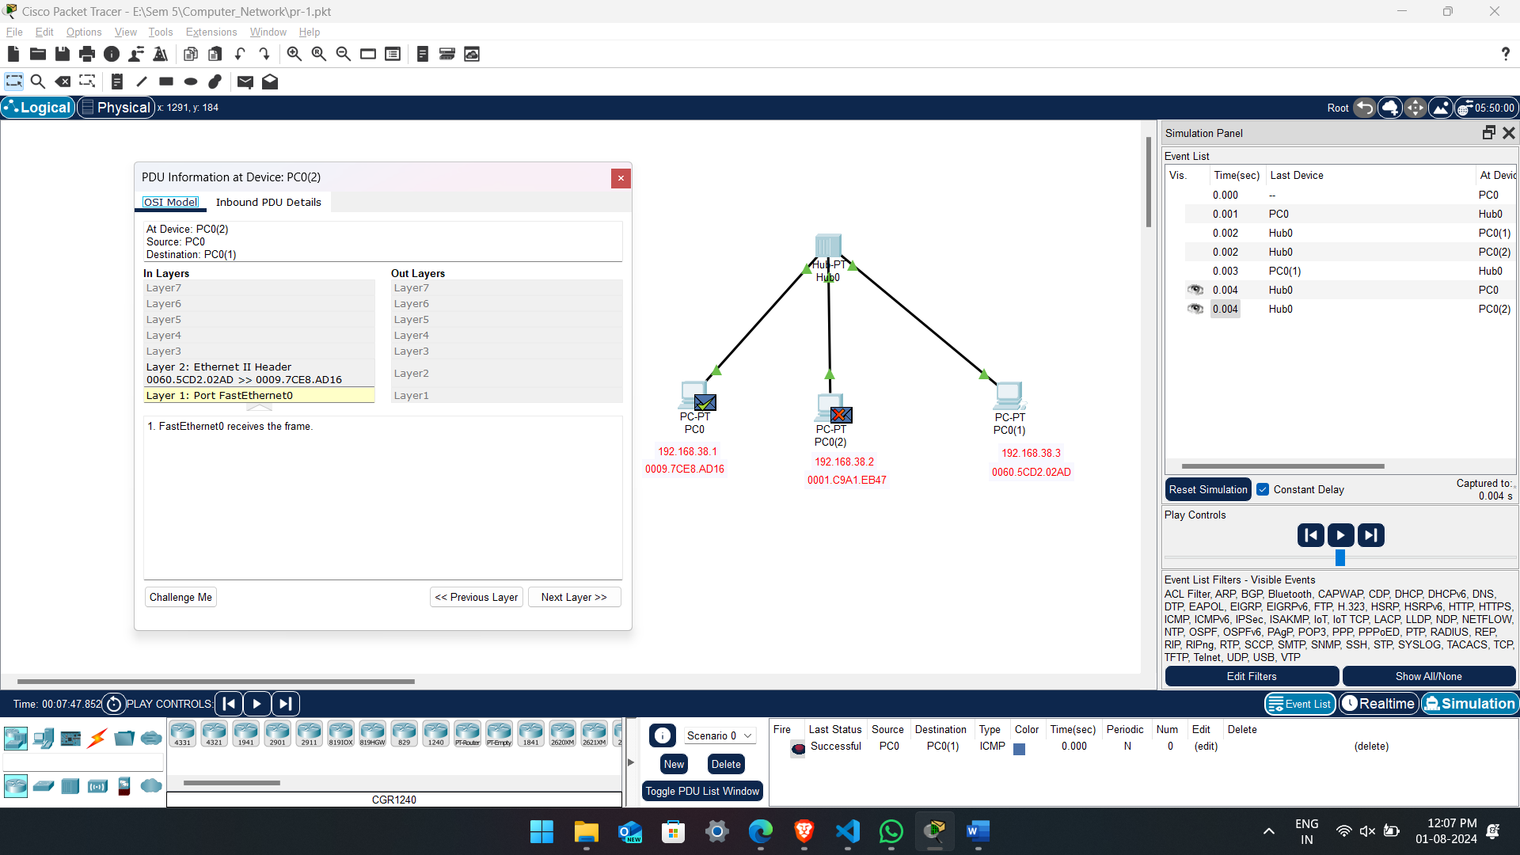

SWITCH:

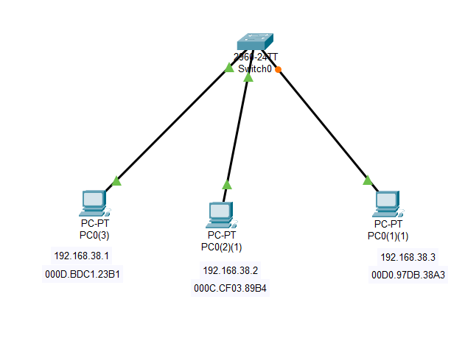

**Task 2:**

To verify the role of Address Resolution Protocol (ARP) in a network of an organization.

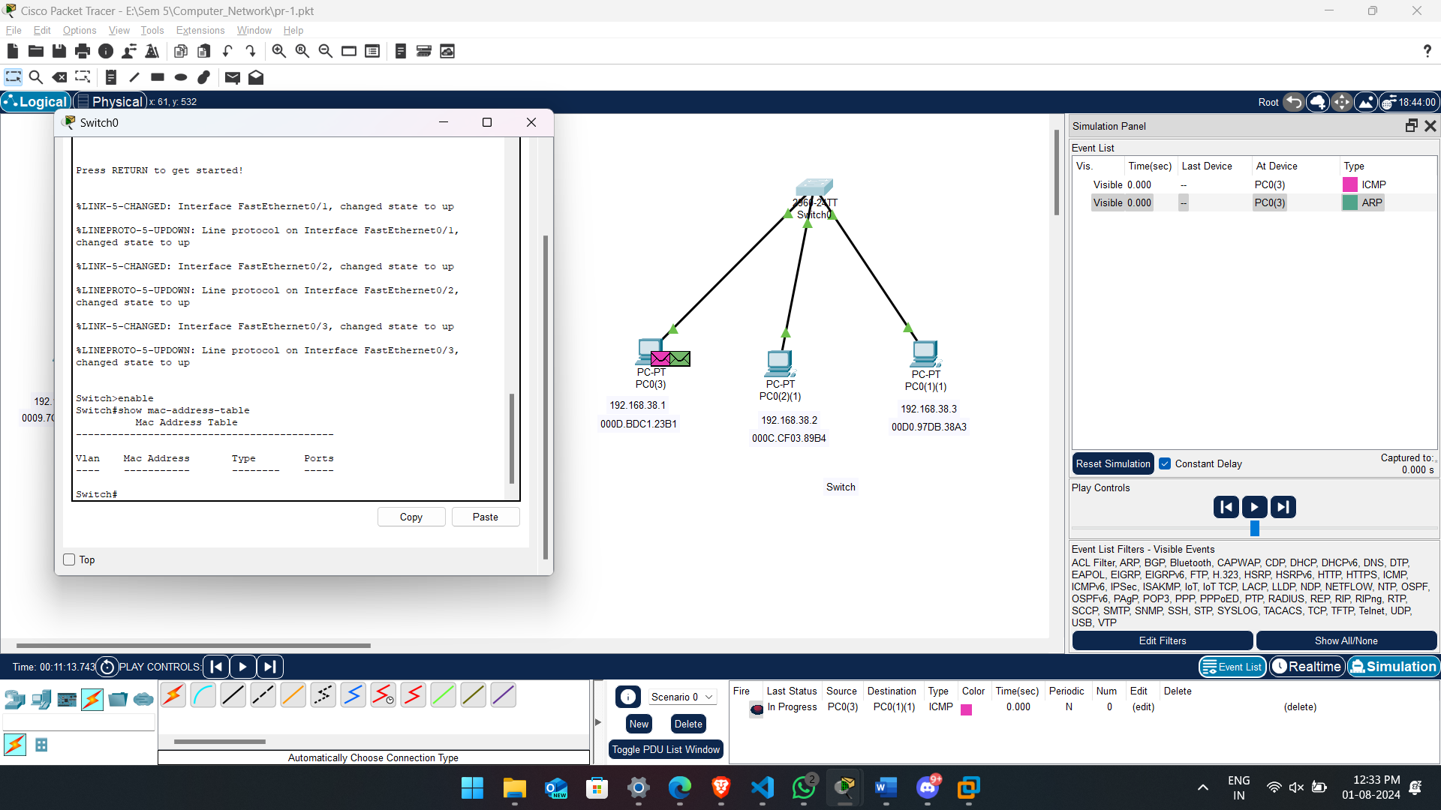

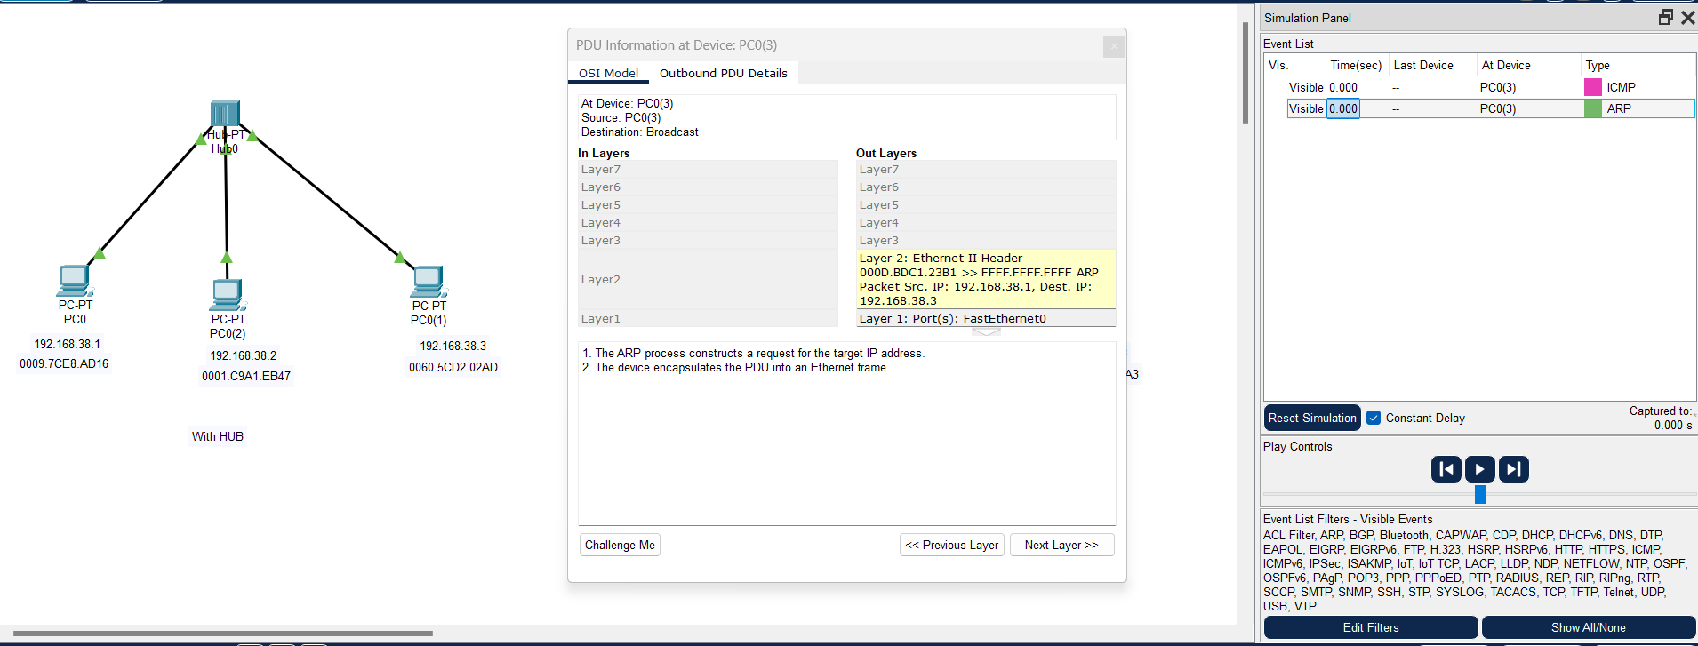

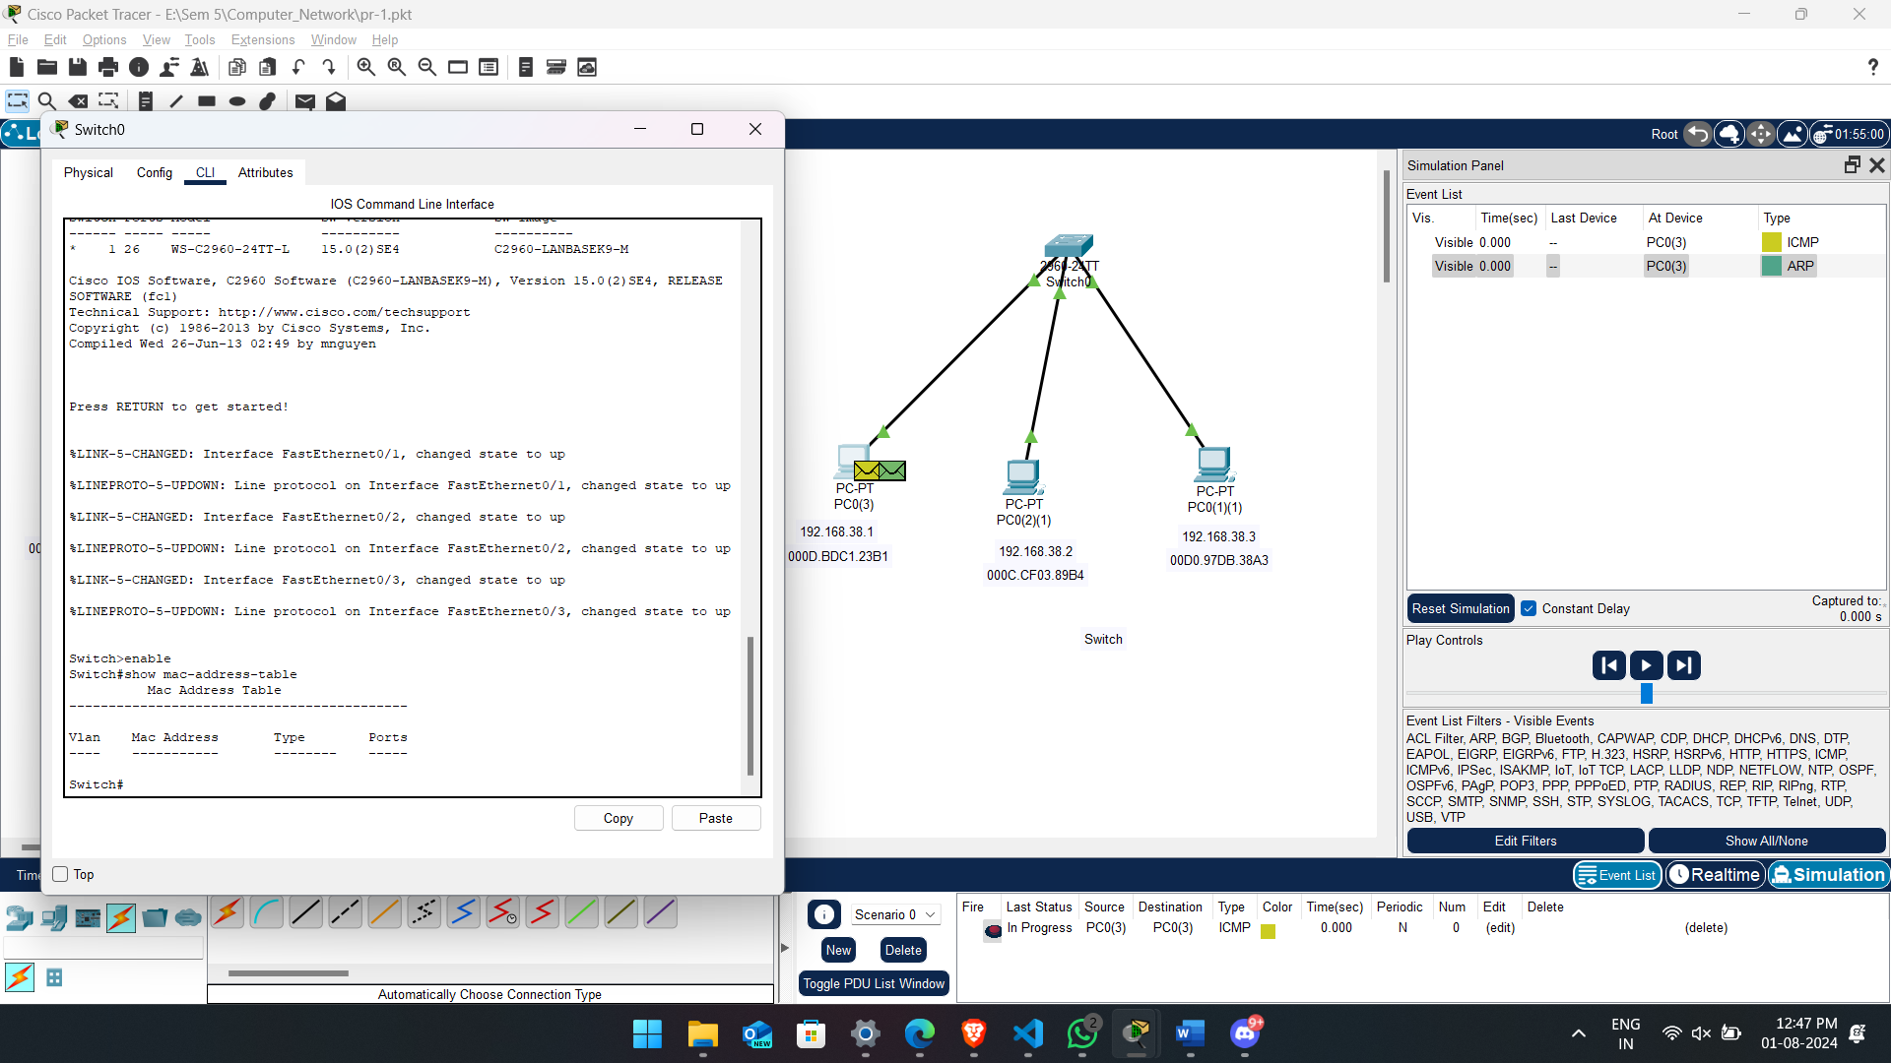

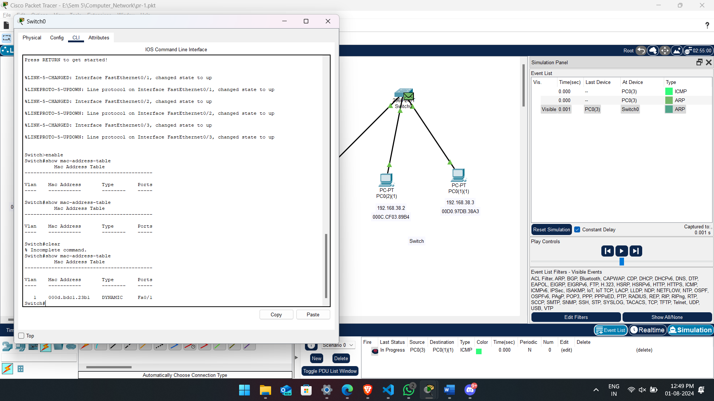

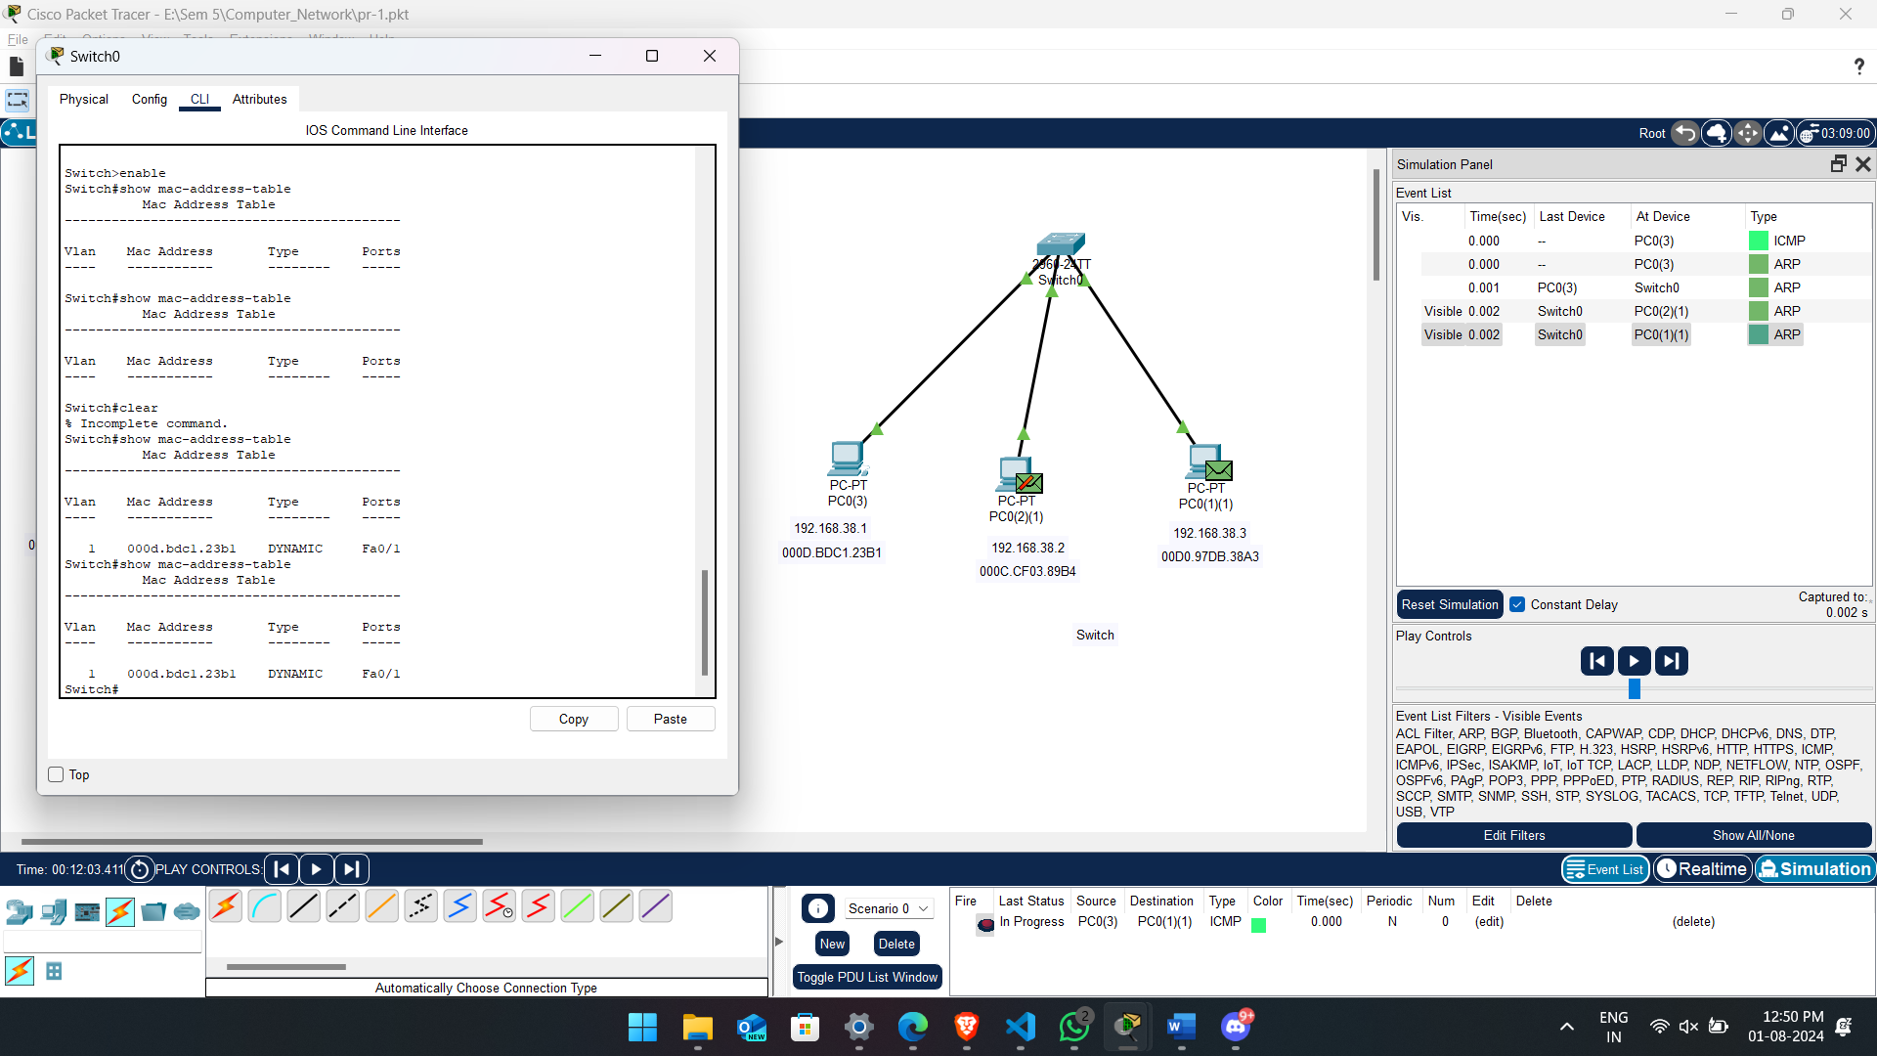 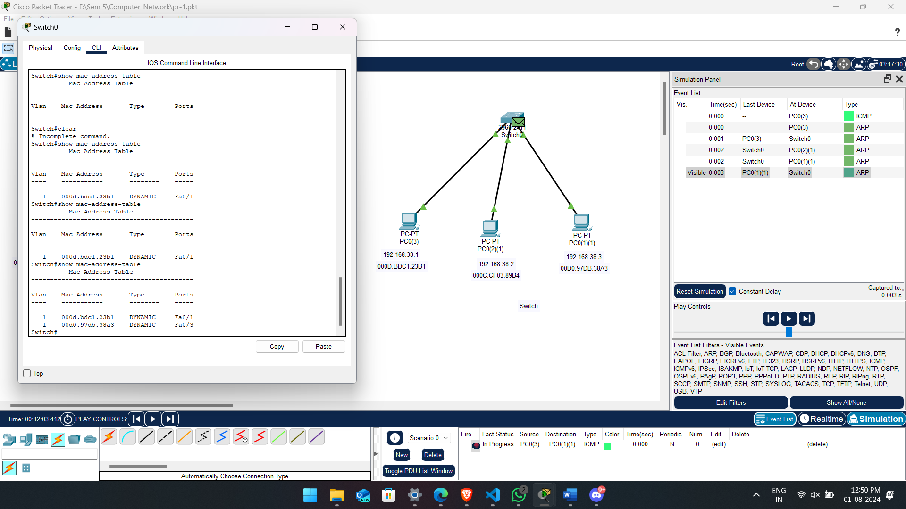 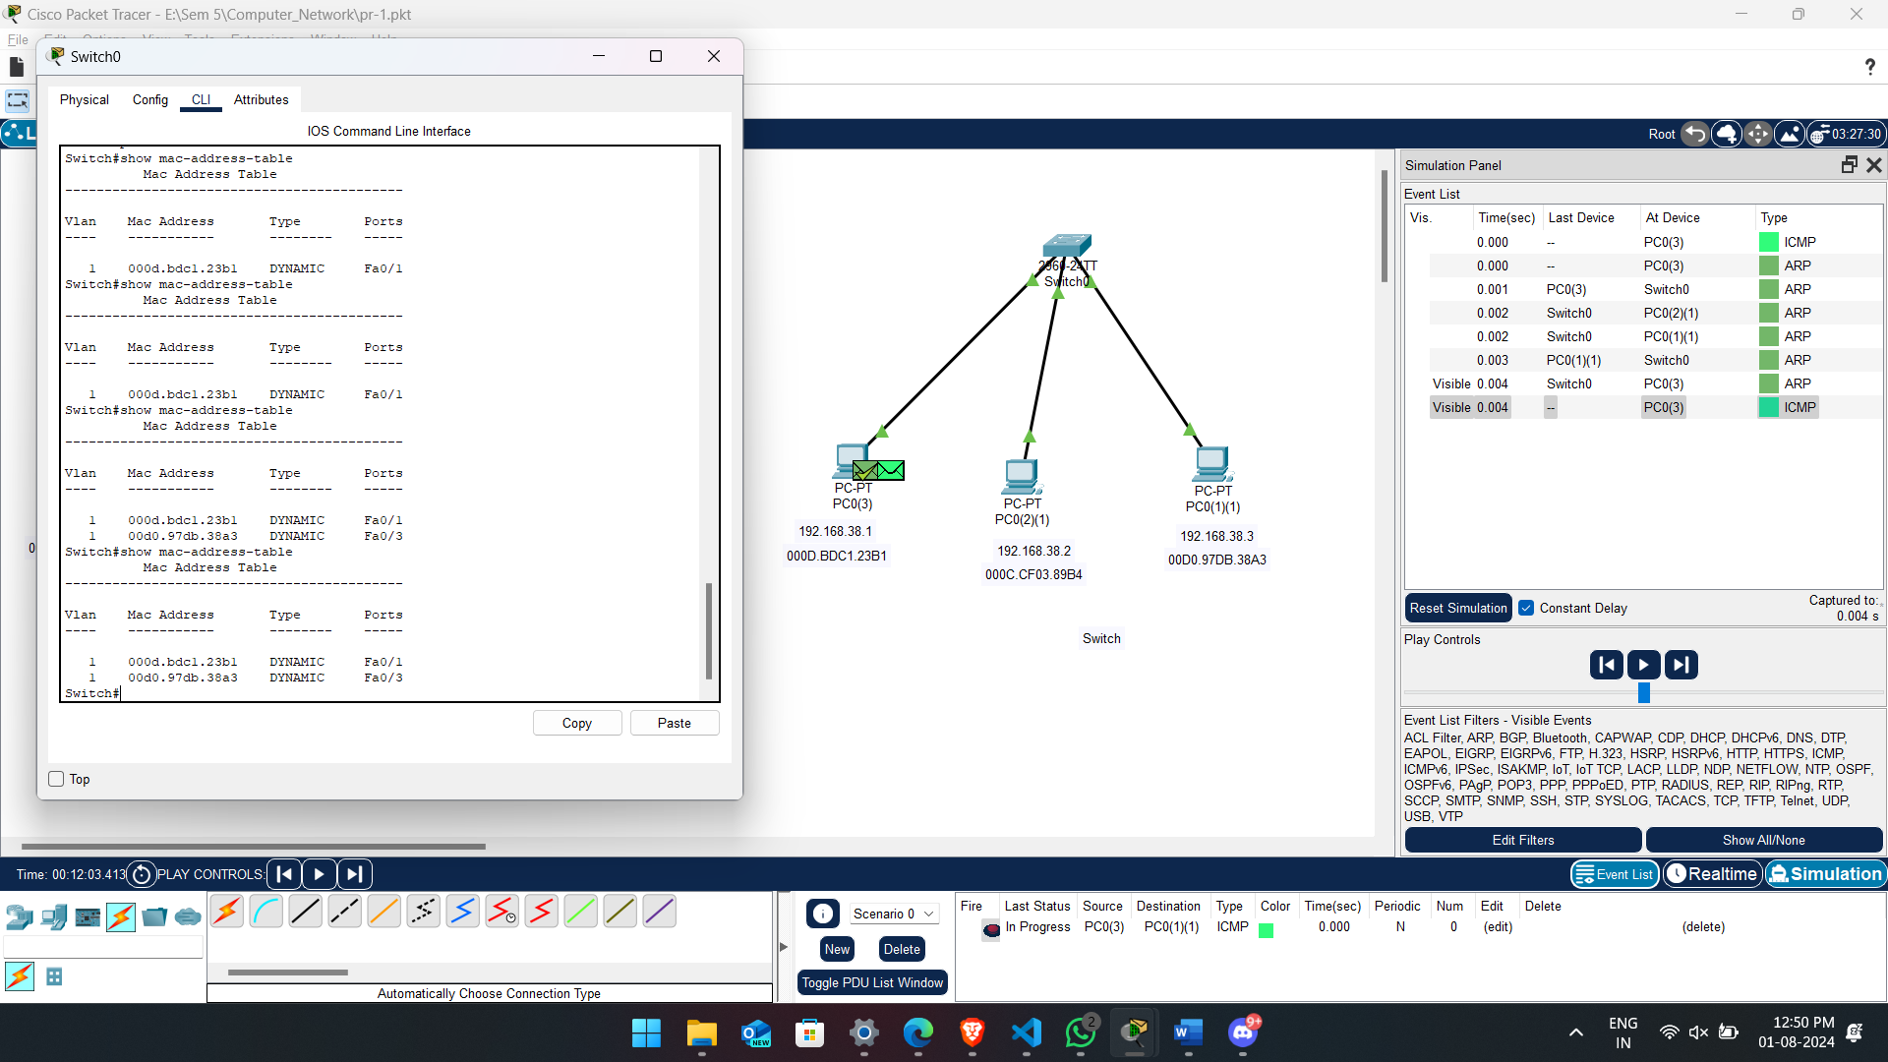

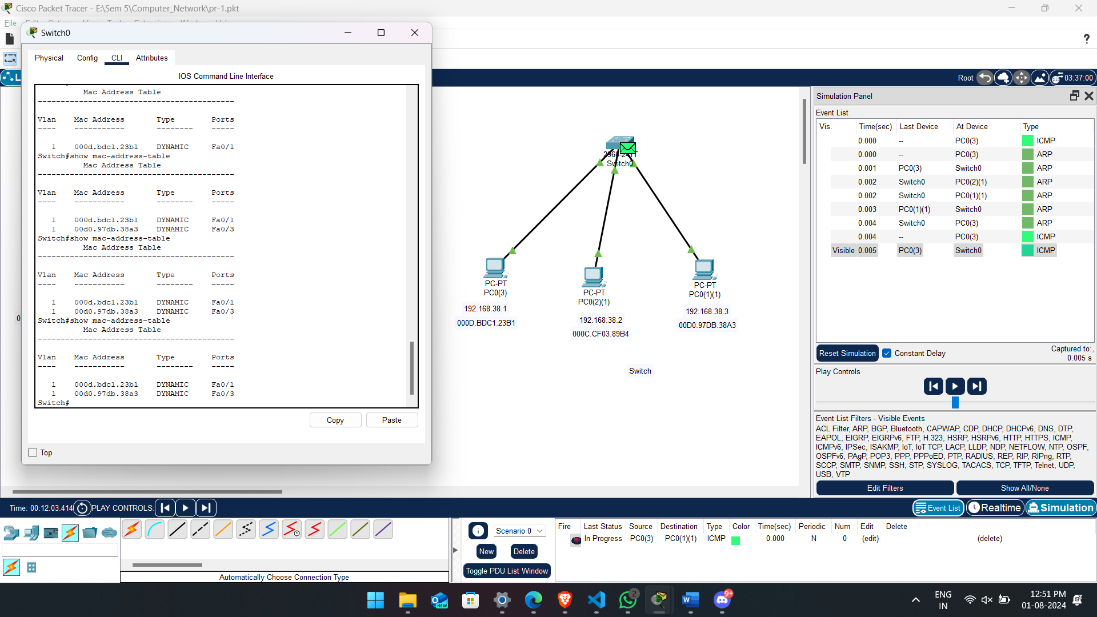 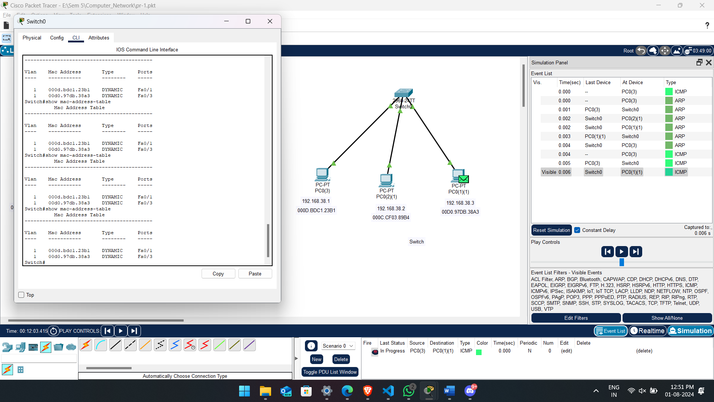

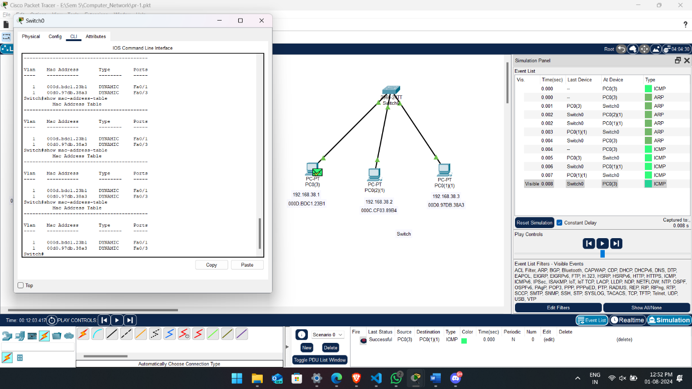

**Conclusion:**

**In simulating a Cisco Packet Tracer, we have shown that switches are better than hubs in terms of networking performance. Unlike hubs that randomly broadcast data to all devices causing congestion and slowing down the system, switches direct packets toward certain devices resulting into fewer collisions thereby increasing speed.**